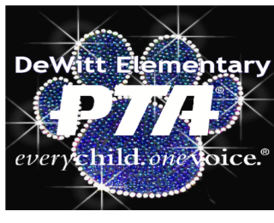
On Saturday, November 11th, the DeWitt Elementary PTA will host its annual Denim and Diamonds Silent Auction at the DeWitt Banquet Center. Our guests will enjoy games of chance, hors d'oeuvres and a cash bar all while bidding on the donations you provide through a silent auction, as well as a spirited LIVE auction. Denim and Diamonds is a great way to support the PTA and the DeWitt Public Schools.

Your commitment to helping the children in our community is sincerely appreciated. With generous donations last year, the Silent Auction brought in over $30,000 in revenue, which went directly to supporting the preschool through sixth grade students of DeWitt by purchasing programs, equipment, and supplies. We hope you will help us reach our fundraising goal for 2017. We are expecting a large group of adults from our school and community to attend this wonderful evening of fun. We would love for you to help make this evening a success by making a tax deductible donation of your choice!

Donated items may include gift certificates, single gift items, or professional services. If you would like to contribute, please complete the information below and return this form by October 9, 2017. Forms can be emailed to dewittsilentauction@gmail.com. You may also contact Jen Roberts at 517-803-7519. Arrangements will be made to have your items picked up or dropped off.

This year, you have a choice of one of four sponsorship tiers if you prefer to make a monetary contribution. To show our appreciation all sponsorship opportunities include your business listed in our program, on our website and social media pages and prominently displayed on our sponsor sign at the auction.

Panther Sponsor- $100 (Includes 2 tickets to the auction)

Denim Sponsor- $250 (Includes 4 tickets to the auction, 4 drink tickets & your logo displayed on the sponsorship sign)

Diamond Sponsor- $500 (Includes 8 tickets to the auction, 8 drink tickets, & your logo displayed on the sponsorship sign)

Platinum Sponsor- $1,000 (Includes 10 tickets to the auction, 10 drink tickets, your logo displayed on the
sponsorship sign & a game of chance package!)

Please print your name as you would like it to appear in print materials:

_____________________________________________________________

Contact Phone No. _______________________ Email: __________________________

Item(s) to be donated: ______________________________________________________________________

Approximate Value of donation $_________

The DeWitt Elementary PTA is tax exempt. IRC §501(c)(3) organization Federal Tax ID # 38-2618924 Federal group exemption # 5017
Checks should be made payable to DeWitt Elementary PTA
and can be mailed to: PO Box 695, DeWitt, MI 48820

